

**Applied Physics for**

**Scientists and**

**Engineers**

**Lab Report: Calibrating the Thermo-Couple by Deﬂection Method**

**Submitted to**

Sir. Haseen Ullah Jan

**Submitted by**

Muhammad Sadeeq

Roll No. 75025 Computer Systems Engineering Sec C FALL 2021



**Thermo-Couple:**

A **Thermocouple** is a sensor used to measure temperature. **Thermocouples** consist of two wire legs made from different metals. The wires legs are welded together at one end, creating a junction. This junction is where the temperature is measured. When the junction experiences a change in temperature, a voltage is created.

A thermocouple can be any junction between two different metals and may be used to measure temperature. Each metal produces a different electrical potential that varies according to changes in temperature. This rate of change is different for each of the metals in the thermocouple, so a thermocouple produces a voltage that increases with temperature.

**Calibrating a Thermo-Couple:**

A thermocouple can be calibrated by plotting the thermocouple’s voltage -temperature curve.



**Apparatus:**

The following apparatus is used to carry out this calibration experiment:

1. 2 thermometers
2. 2 Beakers
3. 2 Test Tubes
4. Galvanometer
5. Spirit Lamp
6. Stand
7. Water
8. Wire
9. Heater Rod

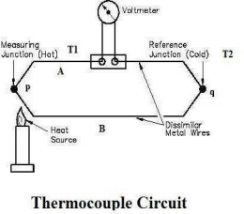

**Procedure:**

Following procedure is followed to carry out this experiment:

1. Test tubes are both completely ﬁlled

with mercury.

2. Test tubes are dipped with eurika and

copper wires respectively and joined

by ends.

3. These joined wires are now became

thermocouples.

4. These test tubes are dropped into

two beakers where a heating rod is

also dipped in one of the beakers.

5. As the temperature is increased

gradually, it gives the voltmeter gives

us gradual readings to correspondent temperature respectively.

6. We also ﬁnd readings mathematically by checking on the temperature difference. 7. At last graph is plotted between and V. We will obtain a straight line.

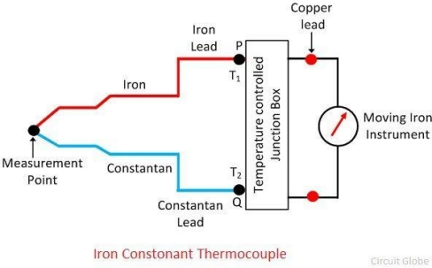

**Readings:**

|  |  |  |  |
| --- | --- | --- | --- |
| Hot Side  Temperature | Cold side  Temperature | Voltage in Volts | △T=T2-T1 |
| 25 ० C | 17० C | 0.1 V | 8 ०C |
| 35० C | 17० C | 0.2 V | 18 ०C |
| 45० C | 17० C | 0.3 V | 28 ०C |
| 55० C | 17० C | 0.4 V | 38 ०C |
| 65० C | 17० C | 0.5 V | 48 ०C |
| 75० C | 17० C | 0.6 V | 58 ०C |
| 85० C | 17० C | 0.8 V | 68 ०C |



**Precautions:**

Following precautions should be taken:

1. Check apparatus for error.
2. Stay away from hot water or hot rod. 3. Don’t touch eureka wire.